# Literature review:

Bennett Foddy, a game design teacher at New York University’s Game Center says, “Video games are governed by microscopic rules”. Having created a dozen of successful free-to-play games he knows pretty much about how to make an addictive game. He adds, “When your mouse cursor moves over a particular box, text will pop up, or a sound will play. Designers use this sort of microscopic feedback to keep players more engaged and more hooked in.” A game is supposed to follow these microscopic rules, as gamers tend to stop playing a game that does not deliver a constant dose of small rewards that make sense given the game’s rule. Those rewards can be as simple as a “ding” sound or a white flash whenever the character moves over a defined space. Foddy adds, “Those bits of micro-feedback need to follow the act almost immediately, because if there is a tight pairing in time between when I act and when something happens, then I will think I was causing it.” One real life example of it is kids pushing all the elevator buttons just to see them light up, and gamers are motivated by the same kind of sense that they are having an effect on the world.

A prime example is represented by the game *Candy Crush Saga.* In 2013, when the game was at its peak, the game solely generated more than $600,000 in revenue per day. The developer of the game, King, has earned around $2.5 billion from the game. Around half a billion and a billion people have downloaded the game and most of them are women, which seems unusual for a blockbuster. Even when the game seems straightforward, it is hard to understand the game’s colossal success. The game’s mechanism was very simple. Players aim to create lines of three or more of the same candy by swiping candies left, right, up, and down, and when they form the matching lines, the candies are “Crushed” and they disappear dropping the candies above them to take their place. When the screen fills with candies that cannot be matched, the game ends. Foddy says, “It is not the rules that made it a success- it is the juice.” Here, the juice refers to the layer of surface feedback, which sits above the game rules, and it plays a huge role in a game’s success even when it is not crucial to a game. Imagine of candies being replaced by gray bricks and none of the reinforcing sights and sounds. Now, the game loses its charm and it is not so fun. “Novice game designers often forget to add the juice. If a character in your game runs through the grass, the grass should bend as he runs through it. It tells you that the grass is real and that the character and the grass are in the same world.” Foddy said. In *Candy Crush Saga,* when a player forms a line of matching candies, a reinforcing sound plays, the score associated with that line flashes brightly, and sometimes you hear words of praise intoned by a hidden, deep-voiced Wizard of Oz narrator. Now, this is the juice of this game.

Juice not only amplifies feedback, but it also aims to unite the real world and the gaming world. *Little Master,* one of the most successful game of Foddy does it very well. It is a cricket game, where a player hits consecutive shots scoring certain points depending upon the trajectory of the shot. If he misses the ball/hits it in the wrong spot, he gets “out” and the game restarts from the very beginning. Foddy said, “When I released Little Master, my wife was working at the head offices of Prada in New York. Much of the finance department consisted of cricket fans from India—and they were hooked.” Foddy managed to keep the game simple as well as true to life. The game’s mechanism was to mirror the swing of the bat in real life by moving the mouse back and forth, and score points by hitting the shots avoiding the clutches of the fielders who might catch the ball before falling into the ground making the player “out”. The game designers call this type of feedback “mapping” as it ties the game to the real world. Foddy says, “Mapping is sort of visceral. For example, you should always use the space bar sparingly. It is a loud, clattery key on the computer, so it should not be used for something mundane, like walking. Its better saved for declarative actions that are not quite as common, like jumping. Your aim is to match sensations in the physical realm to those in the digital realm.”

Likewise, gamers need to lose from time to time as based on the physical realm, which is a long series of losses punctuated by occasional wins. If a game pays out all the time, it is not that fun. A story of David Goldhill, the C.E.O. of the game Show Network illustrates the surprising downside of winning all the time. The story is of a gambler who wins all the time. He says, “The guy thinks he is in heaven because he wins every single bet. Eventually, though, he realizes that he is in hell. It is an absolute torture.” The story illustrates the importance of variable reinforcement. It is not the occasional wins; instead, it is the experience of coming off a recent loss, which is deeply motivating. Motivated perception is crucial for addiction since it shapes how we perceive negative feedback. Hence, many games are designed to get the hope of the players high by displaying near wins. This in turn make players play repeatedly, because to the players it is not a loss but an “almost win”.

Next in line is *Beginner’s luck.* It can make one addicted as it first shows us the pleasure of success and then yanks it away. In other words, it grants us unrealistic ambitions and the high expectations of a more seasoned competitor. The second dose of success in our way is just a mirage and the sense of loss that mounts with each new failure drives us even further until we recapture that early sense of glory. Many game designers recognize it as a powerful hook. Nick Yee, who has a doctorate in communication and studies how games affect players, has written about the role of early rewards in online role-playing games.

One of the factors that attract people to online role-playing games is the elaborate rewards cycle inherent in them that works like a carrot on a stick. Rewards are given very quickly in the beginning of the game. You kill a creature with 2-3 hits. You gain a level in 5-10 minutes. In addition, you can gain crafting skill with very little failure. However, the interval between these rewards grow exponentially quickly. Very soon, it takes 5 hours and then 20 hours of game time before you can gain a level. The game works by gratifying you upfront and leading you down a slippery slope.

When the topic is about developing an addictive video game, we cannot forget *Super Mario Bros* and its creator Mr. Shigeru Miyamoto; who is also known as the Steven Spielberg/Stephen King/Steve Jobs of the gaming world. He is more like an artist that understands what people want better than they do. His involvement can be seen in the second-highest grossing game of all time along with the games ranked fifth, sixth, eighth, ninth, eleventh, twelfth, nineteenth, twenty-first, twenty-third, twenty-fifth, twenty-sixth, thirty-third, and thirty-fourth. His influence and contributions are indescribable. His major finding was that addictive games must offer something to both novices and experts. If the game is designed solely for beginners then it will grow stale too soon and if the game focuses on experts only then it will lose the newcomers before they became masters. In *Super Mario Bros,* he highlighted this theory in real life. The game is welcoming for newcomers as there are no barriers to playing the game. It does not require the players to know about Nintendo console to start enjoying themselves from the very start. There are not any motivation-sapping manuals or any need to grind through educational tutorials in the beginning. The game starts with an empty screen just with “Mario”, the avatar of the game on the very left side of the screen. The empty screen allows us to learn the controls by pushing the Nintendo controller’s buttons harmlessly and randomly. Since we are not learning through a reading guide, we enjoy the sense of mastery that comes from acquiring knowledge from experience. In summary, the first few seconds of gameplay are brilliantly designed to simultaneously do two very difficult things: teach, and preserve the illusion that nothing is being taught at all. While developing it, his primary aim was to build a game which he himself enjoyed playing. For the same reason, he did not consult any focus groups and played the game himself ironing bugs and settling in time. “That’s the point,” he said, “not to make something sell, something very popular, but to love something, and make something that we creators can love. It’s the very core feeling we should have in making games.”

Nir Eyal, the writer of *Hooked* has created his own model named as **The Hook Model** that describes an experience designed to connect the user’s problem to a solution frequently enough to form a habit. He further writes on habits as behaviors done with little or no conscious thought and the convergence of access, data and speed is making the world a more habit-forming place. Creating customer habits provides the business with a significant competitive advantage. **The Hook Model** mentioned in the book consists of four phases: trigger, action, variable reward, and investment.

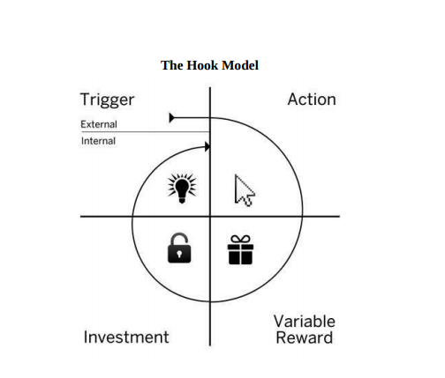

Figure 1: Nir Eyal's The Hook Model

Lev Vygotsky, a Russian psychologist discovered that humans learn the best, and are most motivated, when the material they are learning is just beyond the reach of their current abilities. It all came to him while he was studying how children learn new skills. Vygotsky called this the “zone of proximal development,” which he represented with the following simple diagram:

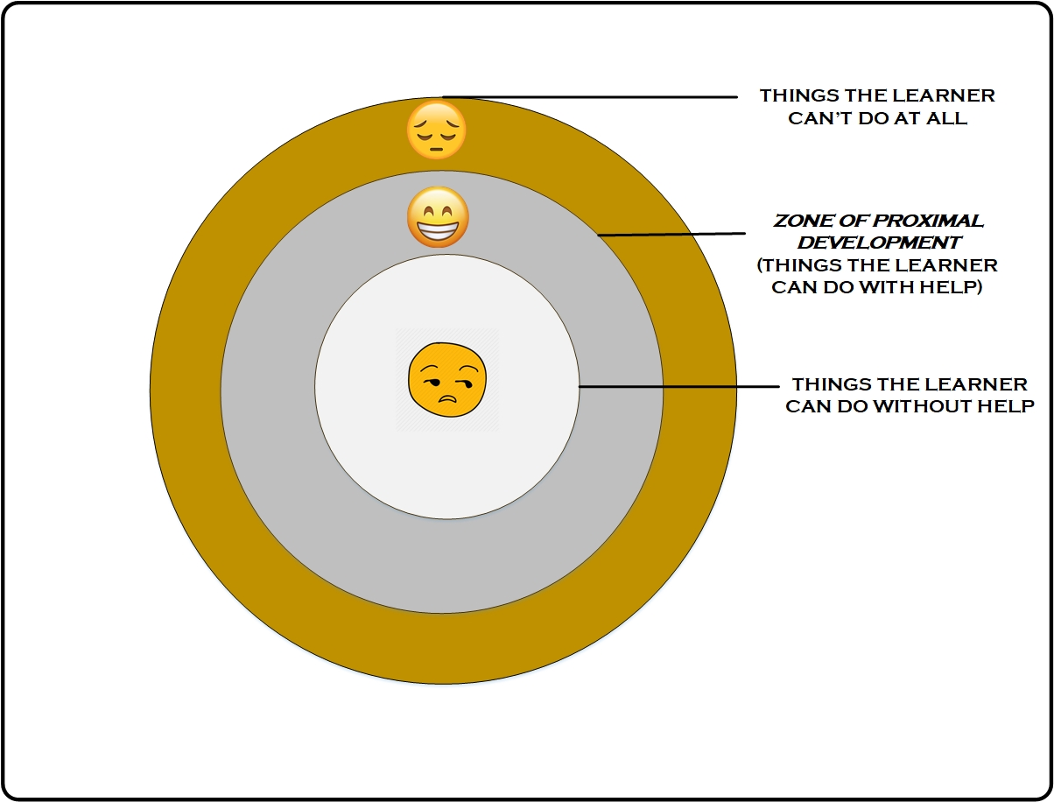

Figure 2: Vygotsky's Zone of Proximal Development

A well-designed game is not led along by a teacher; instead, it creates an illusion of being taught. Remember the first level of Shigeru Miyamoto’s *Super Mario Bros*., which coached novice players through the game’s basics. The same is with *Tetris*, regardless of the player’s abilities, players spend most of the time in the zone of proximal development. The difficulty of the game escalates, but their abilities keep pace—or rather fall just short of mastering the most difficult level they have managed to attain. With it, we do not just learn efficiently; we also enjoy the process and it is deeply motivating.

Next, Mihaly Csikszentmihalyi, a Hungarian psychologist published *Flow* in 1990*,* a book on the psychic benefits of mastering a challenge. As Csikszentmihalyi explained, when people experience flow—also known as entering *the zone—*they become so immersed in the task at hand that they lose track of time. He also created a useful diagram that shows why escalation of difficulty is such a big part of flow.

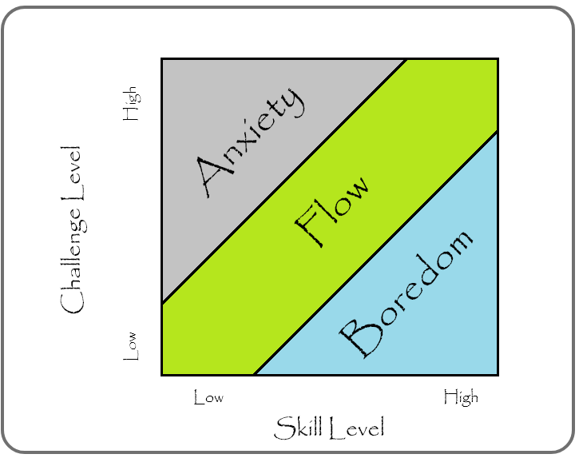

Figure 3: Csikszentmihalyi's Flow Chart

In the figure above, **Flow**—the channel running from the bottom left to the top left represents the experience of tackling a moderate challenge with the skill to master that challenge. Here, both the ingredients are equally important. If the challenge is high but you are less skilled, you experience anxiety and if you are skilled but the challenge is low, boredom. The same is the case in gaming too and experts call this sensation the *ludic loop*—from the Latin *ludere*, for playful. You enter a ludic loop when, each time you enjoy the brief thrill of solving one element of a puzzle, a new and incomplete piece presents itself. The ludic loop can be found in challenging video games, difficult crosswords, repetitive but stimulating work tasks, slot machines that grant you low wins among many losses, and countless other immersive experiences. Ludic loops, like all flow experiences, are very powerful.

Adam Saltsman, the producer of the acclaimed indie game *Canabalt* in 2009, has written astronomically on the ethics of game design. “Predatory games are designed to abuse the way you are wired,” Saltsman said. “Many of the predatory games of the past five years use what’s known as an energy system. You are allowed to play the game for five minutes, and then you artificially run out of stuff to do. The game will send you an email in, say four hours when you can start playing again.” From a normal perspective, it sounds nice as it forces gamers to take breaks and encourages kids to do their homework between gaming sessions. However, during the same break period, the predatory part kicks in. According to Saltsman, “Game designers began to realize that players would pay one dollar to shorten the wait time, or to increase the amount of energy their avatar would have once the four-hour rest period had passed.” Currently, many games in the market hide these down-the-line charges. “Those hidden charges are one way of behaving disrespectfully toward your audience of players,” Saltsman said. “They are a bit like the classic arcade games that charged you a quarter to play the easy opening level, but then forced you to confront a really tough boss at the end of the level. The whole level is easy and fun to play, and then the boss is super hard to defeat. Therefore, you have to put in lots of extra quarters to get to the next fun level. The game advertisers itself as costing a quarter, but there is no way to kill the boss without spending a dollar or more.” The statement is true, as we do not want to admit defeat after spending minutes or even hours deep into the game. The aversion to that sense of loss compels us to feed the machine *just one more time,* repeatedly.

The industry’s biggest game designers can learn rapidly to make their game addictive even if they are not sure how in the beginning. “It is called color coding,” Isaac Vaisberg, a former Word of Warcraft addict said. He explains it with the example of WoW itself. “Say you have two million players already and, and you are trying to figure out what’s most engaging to them. You attach a color to the [computer] code associated with each mission, and see which is most addictive.” These color code allow the designers to analyze the time spent by players on each element within each mission, and how many times they come back to try the mission again. “Since you have a huge sample of players, you can run experiments. Mission A might require you to save something, whereas Mission B is very similar except that you have to kill something. Similarly, Mission C might give you a burst of positive feedback early on, while Mission D, which is otherwise identical, does not give you any feedback.” Isaac said. Now for example, a designer can find out that players spend three times as long playing a mission that requires them to kill rather than save, and return 50 percent more often to a mission that gives them short bursts of micro-feedback. In conclusion, the designers are able to create a weaponized version of the origin game that evolves over time to be maximally addictive. Vaisberg added, “Word of Warcraft is particularly good at this. Over eight years, they have engineered the game to include things people like. FarmVille was huge on Facebook, especially among women, so the World of Warcraft team embedded a version of FarmVille within World of Warcraft to attract female gamers.”

Let us get back to the hook model from Nir Eyal’s *Hooked.* The model consists of four major components, which are trigger, action, variable reward, and investment.

1. **Triggers:**

Triggers cue the user to take action and are the first step in the Hook Model. Triggers come in two types — external and internal. External triggers tell the user what to do next by placing information within the user’s environment. Internal triggers tell the user what to do next through associations stored in the user’s memory. Negative emotions frequently serve as internal triggers. To build a habit-forming product, makers need to understand which user emotions may be tied to internal triggers and know how to leverage external triggers to drive the user to action.

1. **Actions:**

Action is the second step in The Hook. The action is the simplest behavior in anticipation of reward. As described by the Dr. BJ Fogg’s Behavior Model, for any behavior to occur, a trigger must be present at the same time as the user has sufficient ability and motivation to take action. To increase the desired behavior, ensure a clear trigger is present, and then increase ability by making the action easier to do, and finally align with the right motivator. Every behavior is driven by one of three Core Motivators: seeking pleasure or avoiding pain, seeking hope and avoiding fear, seeking social acceptance while avoiding social rejection. Ability is influenced by the six factors of time, money, physical effort, brain cycles, social deviance, and non-routineness. Ability is dependent on users and their context at that moment. Heuristics are cognitive shortcuts we take to make quick decisions. Product designers can utilize many of the hundreds of heuristics to increase the likelihood of their desired action.

1. **Variable reward:**

Variable Reward is the third phase of the Hook Model, and there are three types of variable rewards: tribe, hunt and self. Rewards of the tribe is the search for social rewards fueled by connectedness with other people. Rewards of the hunt is the search for material resources and information. Rewards of the self is the search for intrinsic rewards of mastery, competence, and completion. When our autonomy is threatened, we feel constrained by our lack of choices and often rebel against doing a new behavior. Psychologists call this “reactance.” Maintaining a sense of user autonomy is a requirement for repeat engagement. Experiences with finite variability become increasingly predictable with use and lose their appeal over time. Experiences that maintain user interest by sustaining variability with use exhibit infinite variability. Variable rewards must satisfy users’ needs, while leaving them wanting to reengage with the product.

1. **Investment:**